{{CustomerName}}
{{FullAddress}}

FAO: {{ContactName}}

{{TodaysDate}}

Our Ref: {{ProjectName}}

Dear {{ContactName}},

We would like to thank you for your recent valued enquiry.

We have now reviewed the information and take pleasure in providing the following proposal for your consideration.

Should you require any further assistance, please do not hesitate to contact us.

Yours faithfully,
{{ConsultantName}}

Consultancy Services



Consultancy Services

Scope of Works

Project name: {{ProjectName}}
Data Centre Assessment
Date: {{TodaysDate}}
Customer: {{CustomerName}}

Contents
1. Introduction 4
2. Assessment Aim 4
3. Areas Assessed 5
4. Breakdown of Assessment Areas 5
5. Test Equipment 7
6. Assessment Report 7
7. Price Schedule 9
8. Commercial Details 10
9. Further Information 11

1. Introduction
The Data Centre Assessment is designed to provide a site wide detailed assessment of the electrical & mechanical (M&E) systems technologies, the physical infrastructure, and operational efficiencies of the Data Centre. Initiating from a Single-Line Diagram (SLD) Analysis extensive on-site data from each system levels covering white and grey spaces, including Power Distribution, Airflow Management, Uninterruptible Power Supply (UPS), Outside Heat Exchangers (OHE), IT Racks, Containment, Monitoring, and Generators.
The on-site data is collected and later analysed to provide a comprehensive assessment including infrastructure health status, individual equipment performance, system redundancy checks & highlights of Single Point of Failure (SPOF) that may result in facility operational failures. Focus Is on efficient energy usage, controlling energy costs and increase operational capabilities.
To fully understand the Airflow Management an analysis will be undertaken utilising Computational Fluid Dynamics (CFD) software to establish the thermal footprint of the IT rooms to improve the understanding of the true status of the cooling capability. All the collected electrical & mechanical measurements are reflected in our modelling platforms later to visualize your Data Centre infrastructure.
The collective systems level information will be evaluated through a comprehensive Power Usage Effectiveness (PUE) Assessment and placed in the report with key highlights on each system level improvement opportunities. This in-depth analysis provided by our Accredited Data Centre Consultants addresses the current resiliency level of your facility and grade it to the appropriate Facility Tier Classification after evaluation.
Any additional factors that may cause operational threats such as security breaches and safety hazards are also addressed in the assessment. Our focus as Schneider Electric is to provide you with the most comprehensive assessment offer for your Data Centre to evaluate and increase system resiliency, lower your energy costs, and maximize operational capabilities. With key recommendations providing a constructive and practical action plan to support you in achieving your energy efficiency goals and ensure the highest power availability for your facility and business continuity.

2. Assessment Aim
The assessment is designed to provide a customer with the following end products:
- Identify and detail operational areas of concern across the data centre and the key operating environments
- Evaluation of the current design and operational processes against regulations, standards, and recognised industry best practices.
- Comprehensive review of grey and white space environments
- Identification of Single Points of Failure (SPOF) and operational & safety risks
- Review and evaluation of maintenance strategy
- Identification of energy saving and operational expenditure (OPEX) savings
- Conclusion and summary of assessment findings with supporting evidence from on-site measurements, photographs, and Thermal images
- Forward recommendations designed to address the identified areas of concern and operational improvements to allow a customer to formulate an Action Plan

3. Areas Assessed
As highlighted, this is a non-intrusive assessment and incorporates the following:
- Physical Layout of the data centre
- Rack configuration and management
- Power Distribution incoming feed to IT Power Distribution Units (PDUs)
- Site Electrical & Safety documentation
- Airflow Distribution & Management
- Cooling architecture
- Building Management Systems (BMS)
- Maintenance processes and procedures
- Cross reference to potential Tier classification
- Evaluation and validation of Straight-Line Diagram (SLD)
The assessment will be completed within 3-5 working days, subject to the size and complexity of the given data centre. Schneider Electric has a wide range of subject matter experts (SME's) incorporation data centre, electrical, mechanical, building management systems (BMS), energy efficiency and micro-grid consultants to ensure a detailed and comprehensive data centre assessment.

4. Breakdown of Assessment Areas
The breakdown of the assessment areas but it should be noted that this will vary from data centre to data centre subject to the physical layout, building and system architectures plus the agreed assessment scope agreed with the designated Client. Subsequently, the assessment and report will be tailored to the given data centre and supporting environments:
Physical Layout | - Labelling, floorplans, and documentation  - Operational risks and areas of concern  - Rack layout configurations  - The condition of a raised access floor  - Floor loading capacities  - Quality of supply and return plenums  - Wasted whitespace potential  - Service penetrations into the whitespace  - Fire protection systems & firestop practices  - Access Security & Emergency Exit
Rack configuration & management | - Power distribution to the cabinet (including earthing)  - Effective use of power at cabinet level  - Airflow to cabinet and across the IT equipment  - Quality of cabling and patching  - Identification of bypass and recirculation within rack  - Data cable infrastructure & containment checks  - Cold/Hot aisle containment checks (if applicable)  - Lighting quality (Lux rating)  - Resilience and availability  - Environmental monitoring  - Identification of redundant cabling & equipment  - Rack identification and warning labels  - Space & capacity management review  - Whitespace cleanliness against ISO 14644-1
Power Distribution | - Transformer or Utility point of demarcation  - Main Switchboard & breaker checks  - Uninterruptible Power Supply (UPS) and battery checks  - Review battery monitoring system  - Evaluation of UPS efficiency  - Power Distribution Units (PDUs) and/or Distribution Panels (DPs)  - Remote Power Panels (RPPs) – if applicable  - Rack Power Distribution  - Calculation of the Power Usage Effectiveness (PUE)  - Power cable distribution & containment checks  - Generator rating checks  - Labelling and warning signage  - Review of maintenance records & schedules  - End of Lifecycle (EOL) review  - Lock Out/Tag Out review  - Arc Flash documentation review  - Review and validation of Straight-Line Diagram (SLD) against current design architecture
Cooling Architecture | - CRAC Airflow rates (m³/h) – supply & return  - Floor plenum pressure (positive and negative)  - Air replenishment supply readings  - Outside Heat Exchanger (OHE) checks  - Chiller Unit checks  - End of Lifecycle (EOL) review  - Review of maintenance records & schedules
Airflow distribution & management | - Cabinet Supply and Return Air Temperatures (SAT & RAT) measurements  - Relative humidity (RH) and Dew Point measurements  - Delta T across the IT equipment  - Vented tile and floor pressure readings  - Plenum pressure readings  - Identification of bypass & recirculation  - Review environmental monitoring systems (if applicable)  - Computational Fluid Dynamics (CFD) analysis
BMS & monitoring systems | - Review of alarms and monitoring systems  - Review of environmental internal/external monitoring  - Review of on-site BMS data (if applicable)  - Identification of potential improvements
Tier classification (Upon request) | - Review of the SLD against customer design specification  - Review of resilience and redundancy levels  - Validation of design architecture versus projected Uptime Institute Tier classifications
Table 1: Breakdown of Assessment Areas

5. Test Equipment
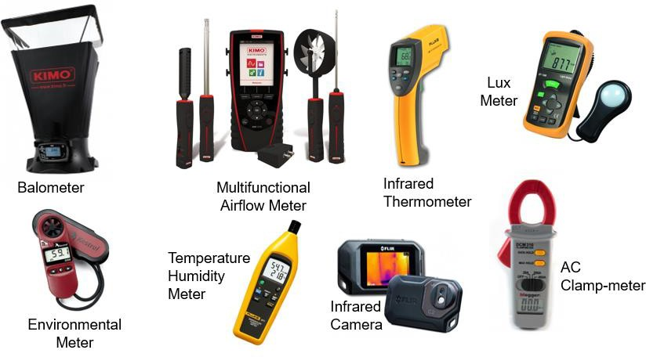
All test equipment is industry approved and fully calibrated, all calibration details will be highlighted within the assessment report.
Figure 1: Assessment Equipment

6. Assessment Report
The report will provide detailed data analysis of problems and issues highlighted during the assessment, with the identified areas of concern broken down as follows:
- Breakdown of assessment data to precisely understand the areas of concern
- Evaluation of operational and business requirements
- Identification energy efficiency and operational expenditure (OPEX) savings
- Single point of failure (SPOF) and operational risk analysis
- Identification of inefficient and obsolete equipment
- Identification of poor safety and working practices
- Identification of areas of technical & operational improvement
- Status of the original design versus the present and future customer demands
- Recommendations and solutions

The overall aim of the report is to provide a customer with the technical structure to establish a comprehensive action plan to resolve the identified areas of concern. The report will be delivered against the agreed assessment scope and formulated from accurate collated data and not assumptions. All observations and conclusions will be supported by appropriate technical evidence utilising photo’s, test result, collated on-site information, and evaluation tables. The report will be formatted covering:
- The assessment scope
- Executive summary
- Audit breakdown/overview
- Audit Assessment (areas audited)
- Observations
- Conclusions
- Recommendations
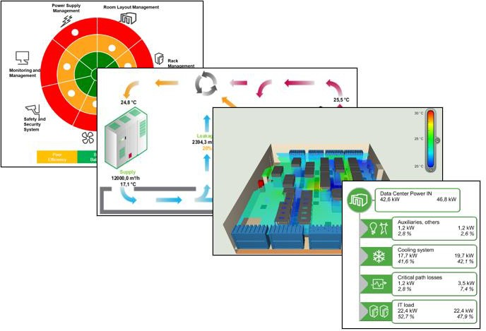
- Appendices and Tables
Figure 2: Report Extraction Examples

7. Price Schedule
Item | Work Description | Price
1 | Place Holder | Placeholder
Total (ex. VAT)

The fee includes all correspondence, meetings, and document reviews pertinent to complete summary report and audit compliance.
Please note: All fees presented are for the pre-defined scope of works, any additional requirements or changes in scope can be met by mutual agreement with the opportunity to revise costs and timescales proportionally.

8. Commercial Details
Validity | Our offer is open for acceptance for 60 days from the date of this quotation ref {{ProjectName}}
Delivery | Based on our present knowledge of availability of personnel and our current programme, we estimate work commencement to be typically 4 working weeks after placement of order and receipt of all information requested in this quotation.  However, should this period be outside your requirements, we would be happy to discuss your needs in more detail.
Order | We would require an official purchase order related to and referencing this proposal. Please send orders to the address and Bid Engineer detailed on the front page of this quotation. A copy of the order should also be emailed to the Bid Engineer.  To be processed without delay your order should include the following information:  - A valid Purchase Order  - Our reference – {{ProjectName}}  - Agreed price  - Formal acceptance of Schneider Electric’s general conditions of sale
Payment Terms | The price(s) quoted are based on the following Payment Terms  - {{PaymentTerms}}  Important Notes:  It is assumed that the project would be completed within 8 weeks of receiving a valid purchase order. Should the project not be completed within this period, we reserve the right to invoice the work completed to that date and review the price of the remaining work according to the newly agreed timescale  Payment Terms offered are subject to satisfactory findings of our routine credit status check.  We understand that the above payments are not subject to any retention.
Conditions | Our offer is made in accordance with Schneider Electric Terms & Conditions UK & Ireland, a copy of which is available upon request or can be found at:  http://www.schneider-electric.co.uk/documents/general/legal-information/Schneider-Electric-Conditions-of-Sale.pdf#page=1  However, we confirm we are prepared to discuss mutually acceptable terms and conditions prior to any contract award should the Schneider terms prove unacceptable.

9. Further Information
Basis of Offer | - Our offer is based on the following requirements.  - Our working requirements.  - Normal working hours would be between 08:00 and 17:00 weekdays and excludes Bank Holidays. Any hours to be worked outside of these times would be charged extra.  - On shore working.  - Unrestricted access to site as and when required (accompanied)  - Work can continue uninterrupted without delays by other parties.  - Unless otherwise stated all work is office based. Site visits and attendance at meetings would be a chargeable addition based on our standard rates.  - Unless a survey has been carried out by Schneider Electric all work is based on information provided to us. We accept no liability for the accuracy or validity of this information how so ever provided.  - Any required changes to the work as a result of inaccurate or invalid information would be a chargeable addition based on our standard rates.
Not Included in Our Offer | We have not included for any of the following:  - Installation of any equipment.  - Commissioning of any equipment  - Attendance at any meetings unless otherwise stated in the scope of works
Standards | Schneider Electric Ltd complies with and works within the following standards:  - ISO14001  - ISO9001  - The Management of Health and Safety at Work Regulations.  - Health and Safety at Work Act.  - BS7671:2008 Requirements for Electrical Installation  - The Provision and Use of Work Equipment Regulations.

